Introduction

Binary Tree is also a graph but unidirectional. So, we can apply BFS and DFS on it for traversal (searching a node).

BFS has 3 main types of traversal
- Pre-order traversal
- In-order traversal ---- Always traverses nodes of BST(Binary Search Tree which is symmetric) in ASCENDING order
- Post-order traversal

One additional type of traversal

- Boundary traversal (BoundaryTraversal.java)

BFS uses stack for recursive method calls.

DFS has below types of traversal
- Level-order traversal
- Vertical-Order traversal (internally uses Level-Order traversal)
DFS uses queue to keep track of nodes in level order. It uses stack for recursive method calls.

https://en.wikibooks.org/wiki/A-level_Computing_2009/AQA/Problem_Solving,_Programming,_Operating_Systems,_Databases_and_Networking/Programming_Concepts/Tree_traversal_algorithms_for_a_binary_tree#Breadth_First_traversal

BFS Traversal (Level Order, Vertical Order Traversals)

See ‘LevelOrderAndVerticalOrderTraversal.java’

Video

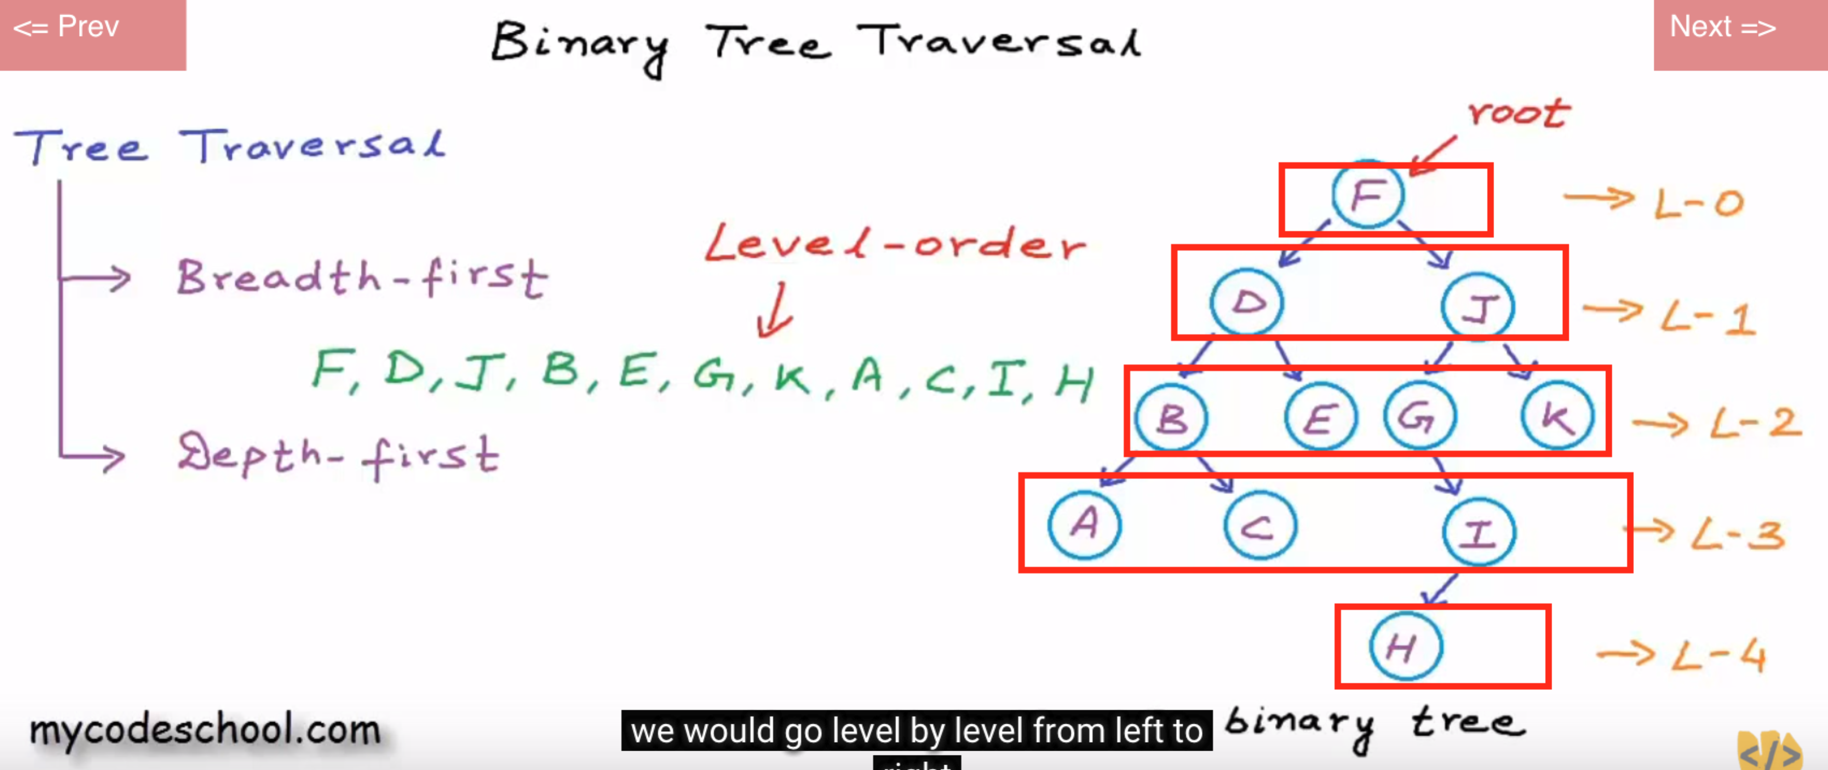

1) Create empty queue and push root node to it.
2) Do the following when queue is not empty
Pop a node from queue and examine it. if it is a node that you are looking for then return it, otherwise
Push left child of popped node to queue if not null
Push right child of popped node to queue if not null

public void levelOrderTraversalIteratively(TreeNode root) {
if(root == null) return;
Queue<TreeNode> queue = new LinkedBlockingQueue<>();
queue.add(root);
while(!queue.isEmpty()) {
TreeNode polledTreeNode = queue.poll();
System.out.print(polledTreeNode.data+", ");
root = polledTreeNode;
if(root.left != null) {
queue.add(root.left);
}
if(root.right != null) {
queue.add(root.right);
}
}
}

PreOrder, InOrder, PostOrder (DFS) Traversals

See “BST.java”

3 types of DFS (Deapth First Search) Traversals
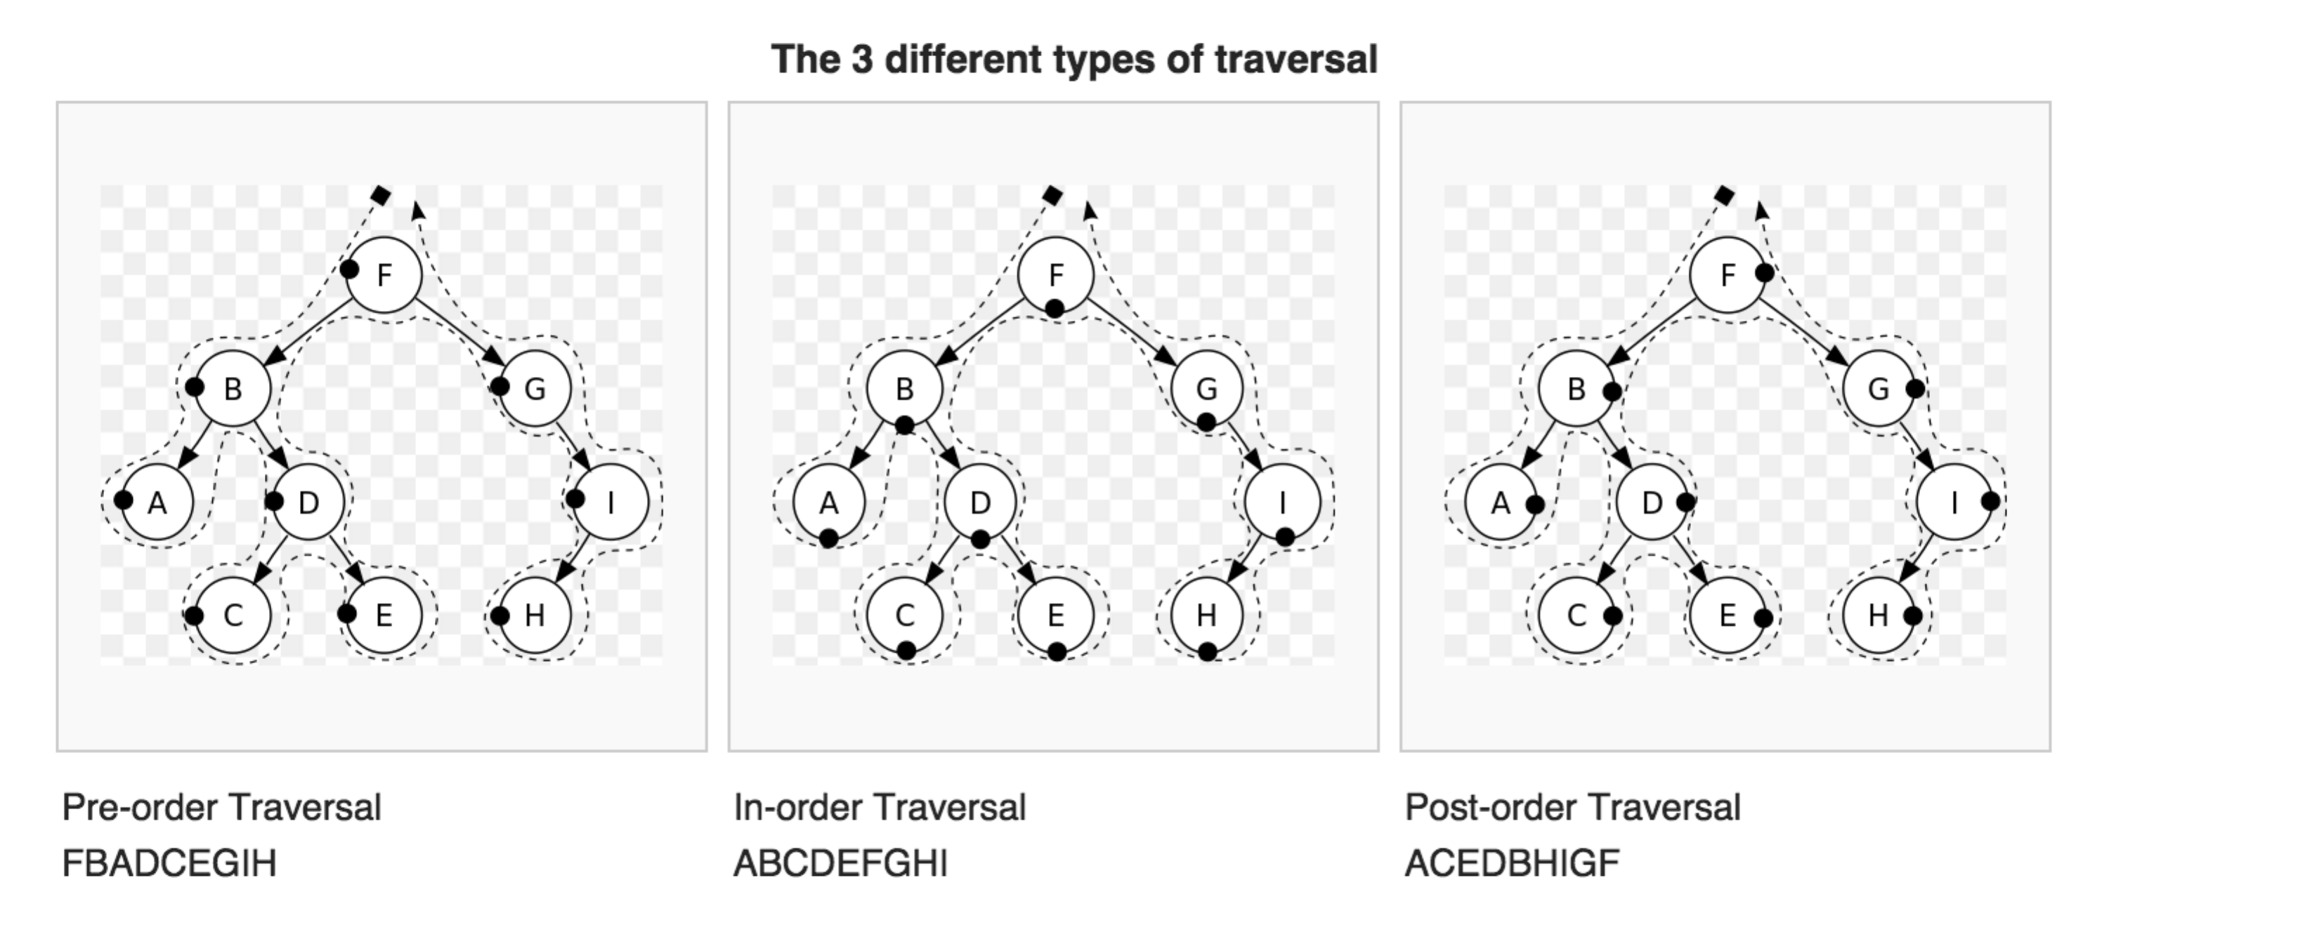

public void preOrderTraversal(TreeNode treeNode) {
if (treeNode == null) return; // exit condition
visitTreeNode(treeNode); // visit current node
preOrderTraversal(treeNode.left); // go left
preOrderTraversal(treeNode.right); // go right
}

public void inOrderTraversal(TreeNode treeNode) {
if (treeNode == null) return; // exit condition
inOrderTraversal(treeNode.left); // go left
visitTreeNode(treeNode); // visit current node
inOrderTraversal(treeNode.right); // go right
}

public void postOrderTraversal(TreeNode treeNode) {
if (treeNode == null) return; // exit condition 1
// exit condition 2,3...
// If you put any one or more exit condition here, then it will stop traversing a child tree (left and right) further. it will set the returned value to parent recursive call.
// In this case it is possible that one of the left or right child tree traversal result can be null. you need to consider that scenario. e.g. FindLowestCommonAncestorInBinaryTree.java
postOrderTraversal(treeNode.left); // go left --- not same as "treeNode = treeNode.left; postOrderTraversal(treeNode)"
postOrderTraversal(treeNode.right); // go right --- not same as "treeNode = treeNode.right; postOrderTraversal(treeNode)"
visitTreeNode(treeNode); // visit current node
}

